Criterion B: Design

Edit: This Design was made prior to the integration of the newly added printable text file option, as well as some minor changes in the looks and some functions of my program (such as the numerous sort options, refresh button, specific search radio button, and the choice to instead create a JTable layout).

Diagram:

The Diagram below shows the interface of my program, and is what my program will display when the user interacts with it:
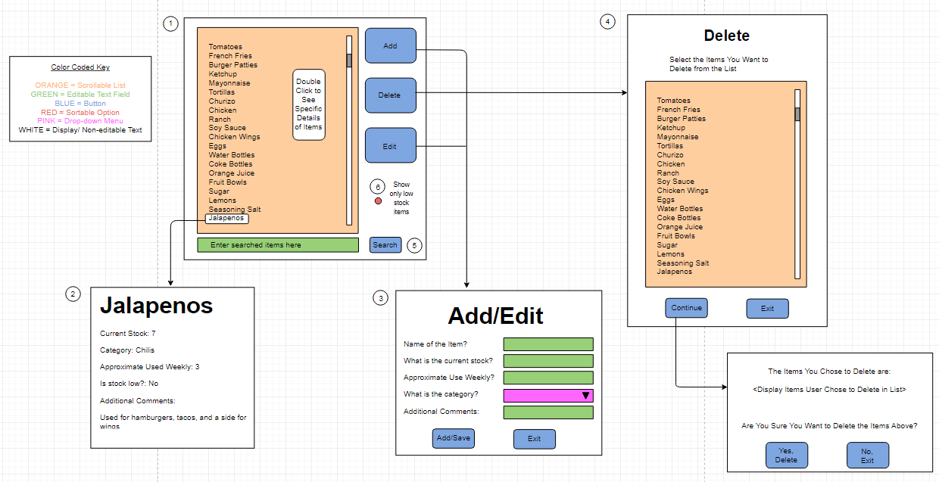

Descriptions of Main Features & Functions

- Main Menu Display

- Item Display

- Add Button /Edit Button

- Delete Button

- Search Button

- Sort Button
Flow Chart:

